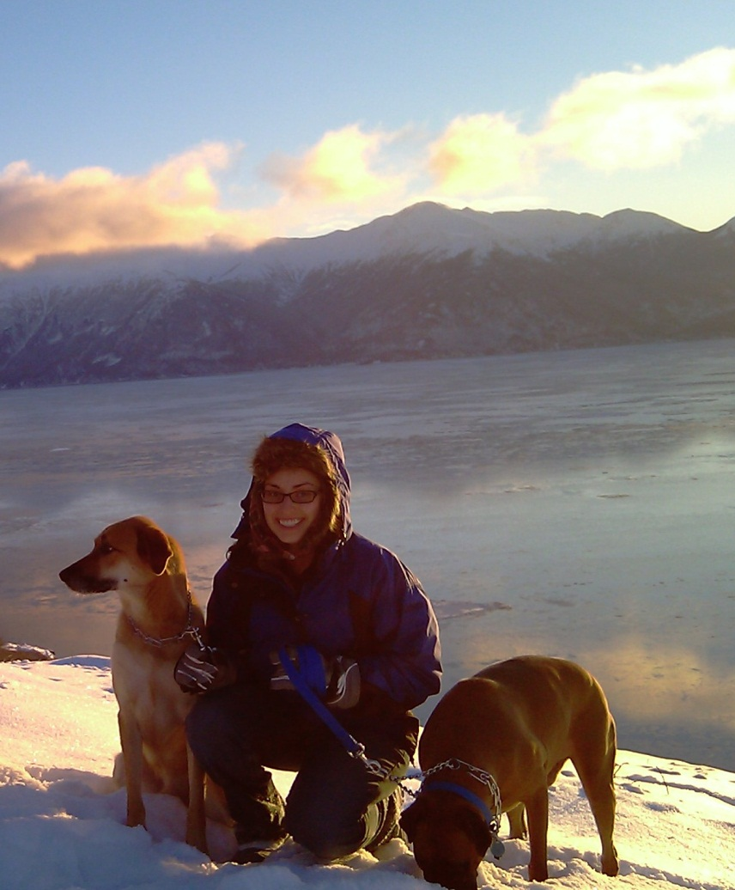
Danielle Giroux is a third year student in the UAA-UAF Clinical-Community Psychology PhD program and is very invested in the unique integration between the disciplines of clinical and community psychology that UAA-UAF has to offer. She is primarily interested in research involving youth populations and substance abuse prevention and/or treatment. Danielle has a master’s degree in social work from Hawaii Pacific University. While in Hawaii Danielle participated in the development of a community based, drug prevention program implemented in rural schools. Her social work training has promoted Danielle’s interest in macro level changes and social justice issues as they pertain to historically oppressed populations.
Throughout her time in the program Danielle has worked on several faculty research projects, among them are the Location-Based Monitoring and Intervention System for Alcohol Use Disorders (LBMI-A), the Alaska Native Peoples and Racial Microaggressions, and the Alaska Native Cancer Survivors project. Danielle is currently working as a service assistant through the Alaska Native Tribal Health Consortium where she assists with domestic violence, suicide and substance abuse prevention initiatives. In addition to her research work Danielle has also completed clinical practicum training at Alaska Children’s Services and has served as an adjunct faculty for the Hawaii Pacific University school of Social Work.
Danielle currently serves the UAA student body as the coordinator of the UAA Graduate Student Association and as the PhD Student Representative. As student representative Danielle is responsible for presenting student concerns and suggestions at the bi-weekly faculty meetings as well as promoting student to student mentorship within the program. In her free time Danielle enjoys yoga, cooking and murder mystery parties. Danielle welcomes any questions about her work or the program. Please feel free to contact Danielle at: ddgiroux@alaska.edu

